KING MONGKUT’S INSTITUTE OF TECHNOLOGY LATKRABANG

SCHOOL OF ENGINEERING

Group 7 of **Robotics and AI: Sec 2**

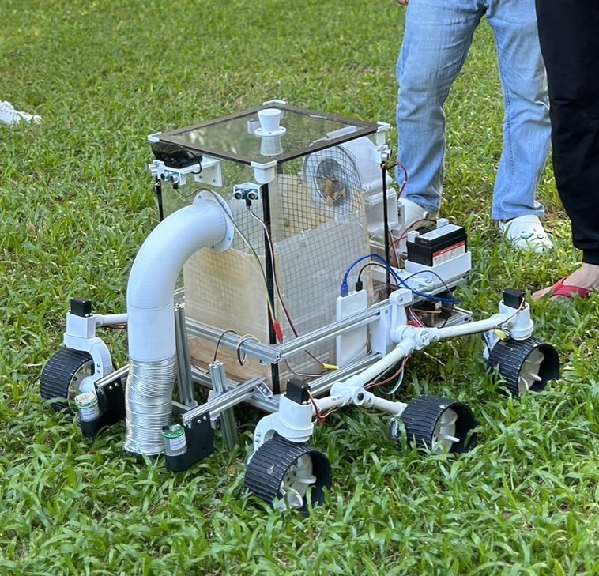

**LEAVE COLLECTOR ROBOT**

01416304 - FEEDBACK CONTROL

**INSTRUCTED BY:** PROF. DR. PITIKHATE SOORAKSA

**NAME:** PAING, PYAE, TANAKORN, SURIYARAT, THITIPHAN, RACHATA, SWAN, THURA, SITTIPON, SORNPAWEE

**ID NUMBER:** 65011416, 65011497, 65011563, 65011557, 65011598, 65011500, 65011683, 65011685, 65011539, 65011546

**Tables of Contents**

1. **Concepts and Drawings**

1.1 - Suspension System 3

1.2 - Leave collecting mechanism 3

1.3 - Navigation 5

1. **Design**

2.1 - Components and Parts 7

2.2 - Kinematics and Dynamics 12

2.3 - Control System 13

1. **Implementation**

3.1 Hardware 14

3.2 Software 15

1. **Test Result**

4.1 Overall test result 26

4.2 Kalman Filter 26

4.3 PID 27

4.4 Sensor Calibration 27

1. **Conclusion**

5.1 Concluding Remarks 28

5.2 Suggestion 28

Project Code Github 28

Member Participation 28

## 

## **Concepts and Drawing**

### **1.1. Suspension System**

**Purpose: To be able to move on different terrain**

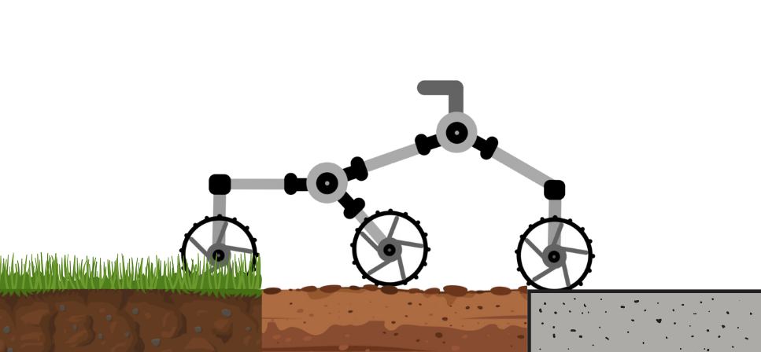

The robot design is based on the Mars Perseverance Rover. It was equipped with the **Rocker-Bogie Suspension** system , which allows the robot body **to fully stabilize relative to the ground** even on uneven terrain.

## **1.2. Leave-collecting Mechanism**

**Purpose: To be able to collect leaves as much as possible**

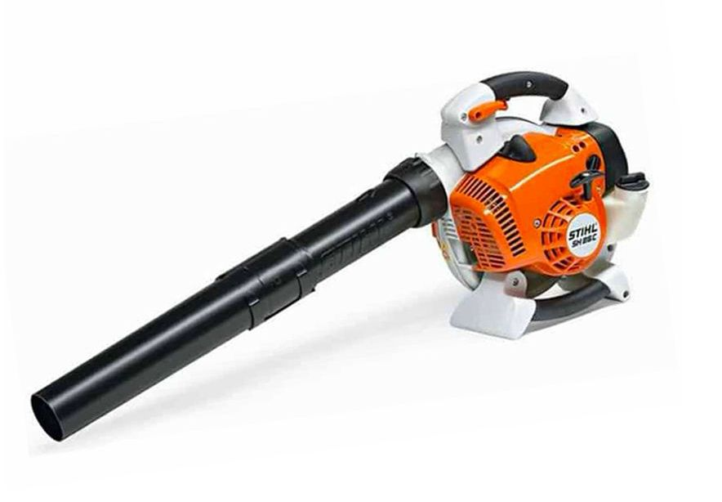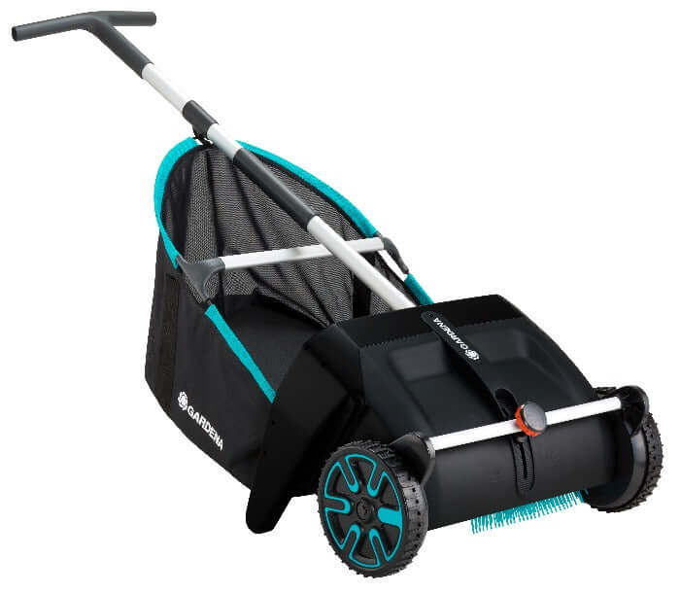

There are several options available for the leave-collecting mechanisms. The following shows some examples. We needed an ensured mechanism that can work on all terrains, (side road, soil, grass). Thus, we decided to use the **“Vacuuming”** mechanism to suck leaves from the ground no matter what type of terrain.

**1.2.1. Vacuuming Mechanism**

**Purpose: To have a powerful vacuuming system**

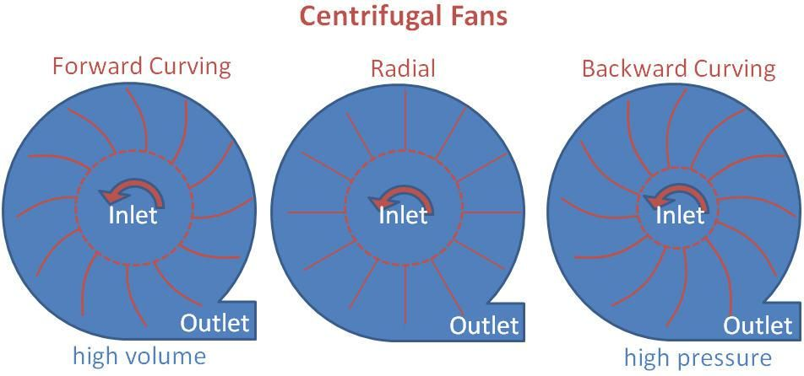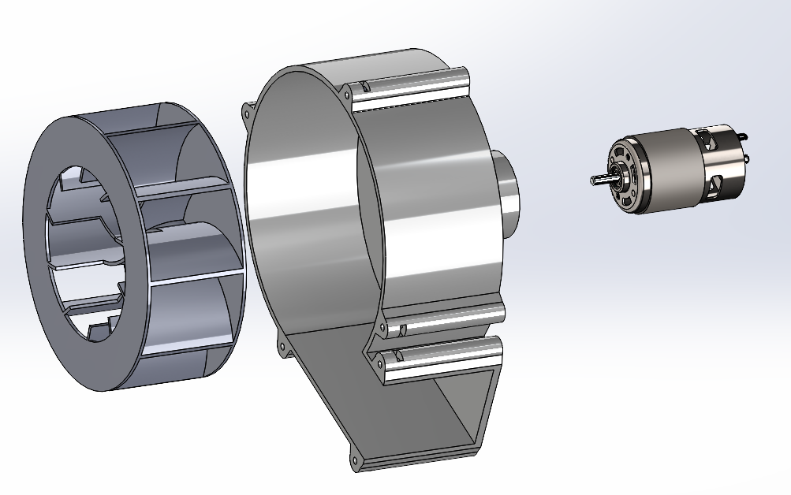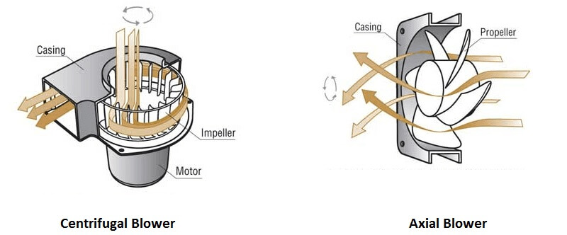

There are several vacuuming mechanisms available, Among them, **the centrifugal pump** is the most suitable choice for our project for its **high pressure pumping power**.

**1.2.2. Leave Take-Out System**

**Purpose: To take out the leaves easily**

We create a **vacuum box** to take in the leaves and inside there is a **basket made with net** which does not affect the air flow but prevents the leaves from entering the impeller. Moreover, we make sure the box is sealed to prevent leaking air which might reduce the vacuuming pressure. 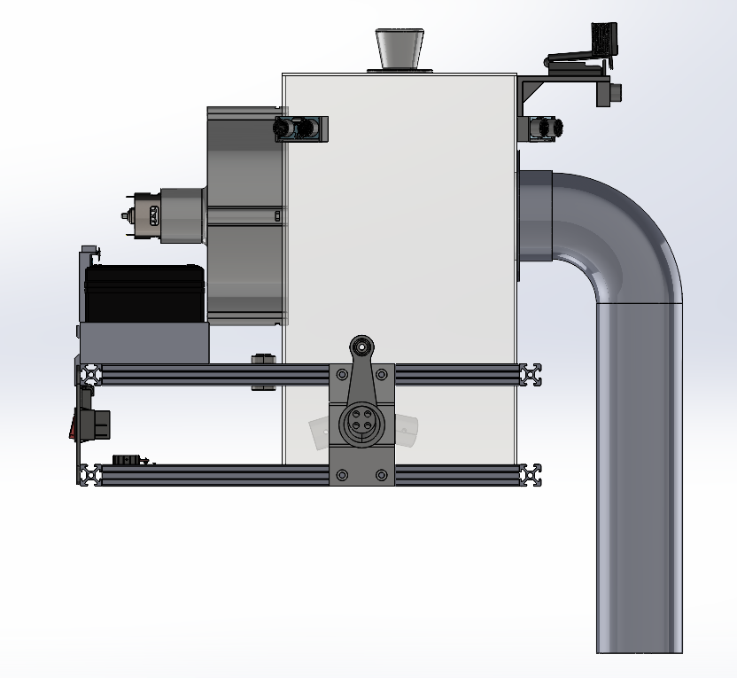

## **1.3. Navigation (Dead Reckoning)**

**Purpose: To be able to know the robot’s position relative to the original position**

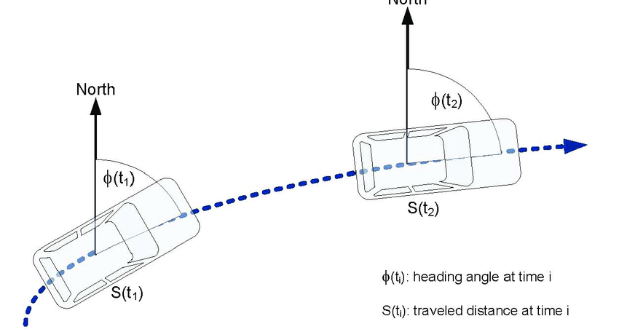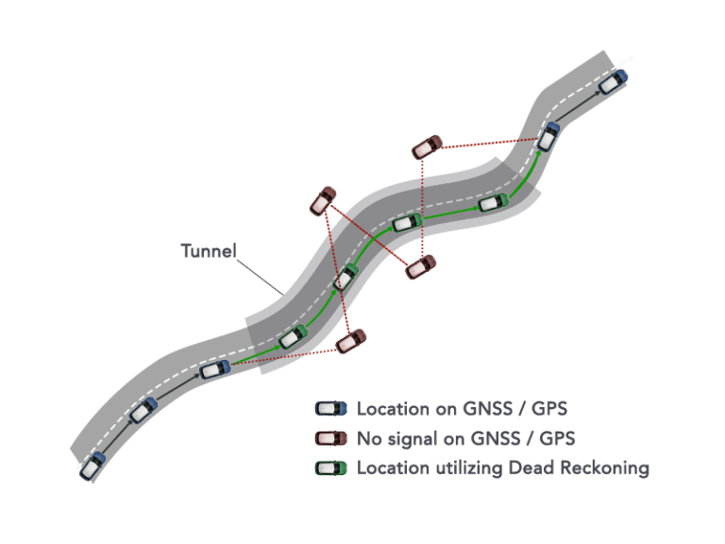

Initially, we tried to detect the robot position by sensor fusion of GPS sensor and accelerometer sensor but the data of GPS sensors that we bought were not precise enough. As we are having a budget limit and the robot will only be run for a short distance, we decided to switch to the **Dead Reckoning Method of Navigation** which calculates the position of the robot from the data of **the motor encoder(Linear Displacement) and IMU sensor(Orientation).**

## **1.3.1. Obstacle Avoiding**

**Purpose: To be able to avoid the obstacles along the path while keep tracking on the path**

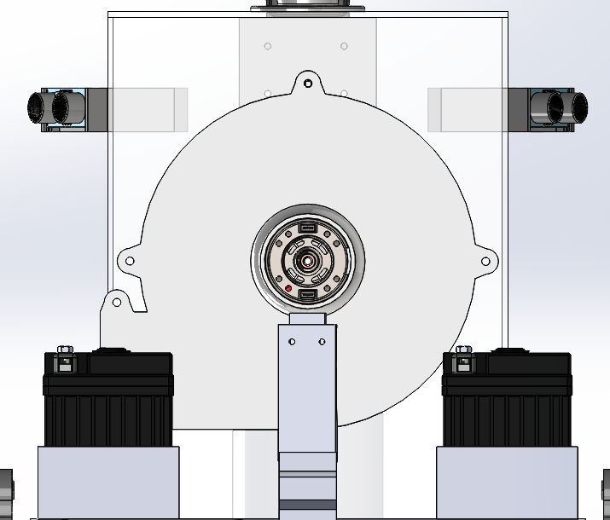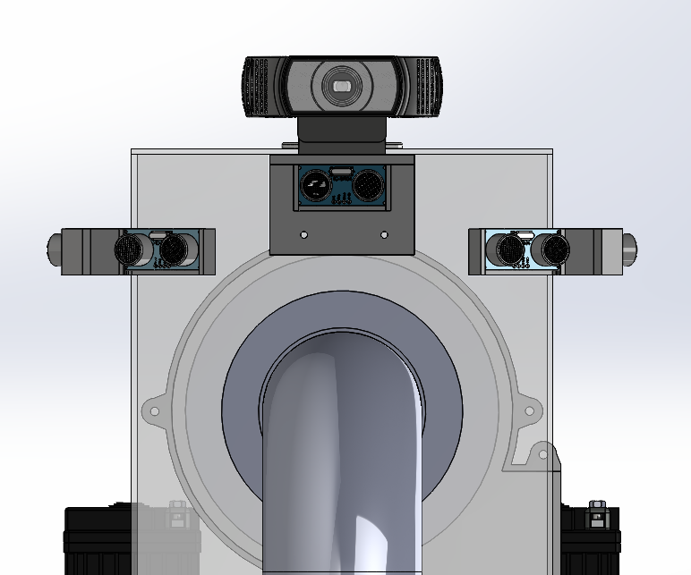

We use ultrasonic sensors to detect the obstacles and camera to know the relative degree of obstacle from the robot so that the robot can smoothly turn towards the movable area. We use two more ultrasonic sensors at the back so that it can track the original path once it passes the obstacle.

## **1.3.2. Steering System**

**Purpose: To be able to turn the robot smoothly**

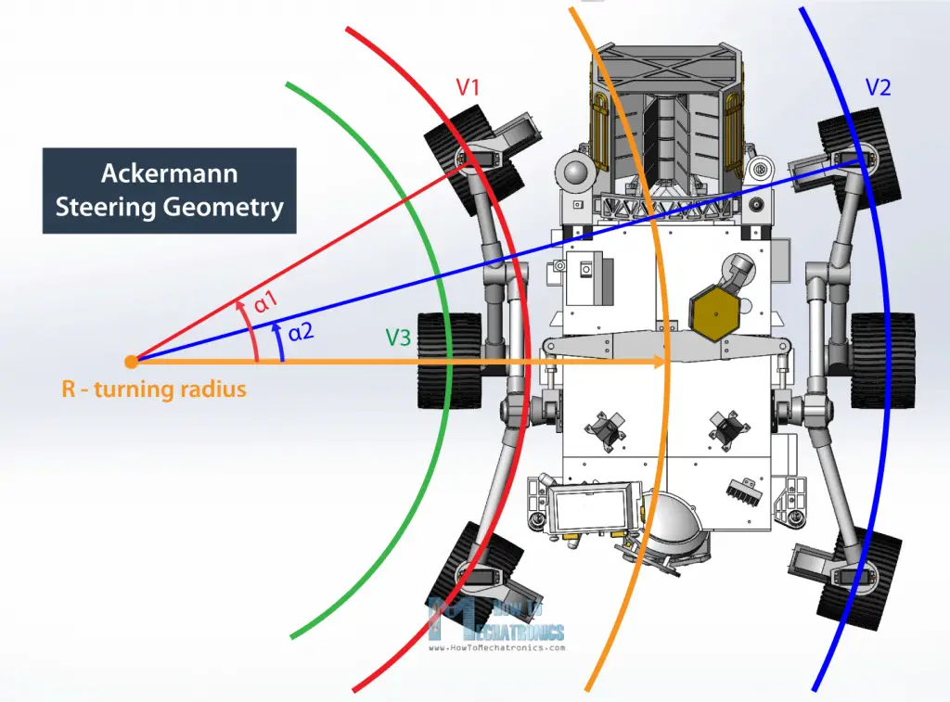

In order to avoid the tire slipping and have efficient turning, we integrated **Ackermann Steering geometry**. It is one of the basic steering mechanisms which does not require much calculations. Since it is hard to implement the four-bar linkage steering to this type of medium-sized project, we decided to use **servo motors** as main actuators for **turning wheels**

## **Design**

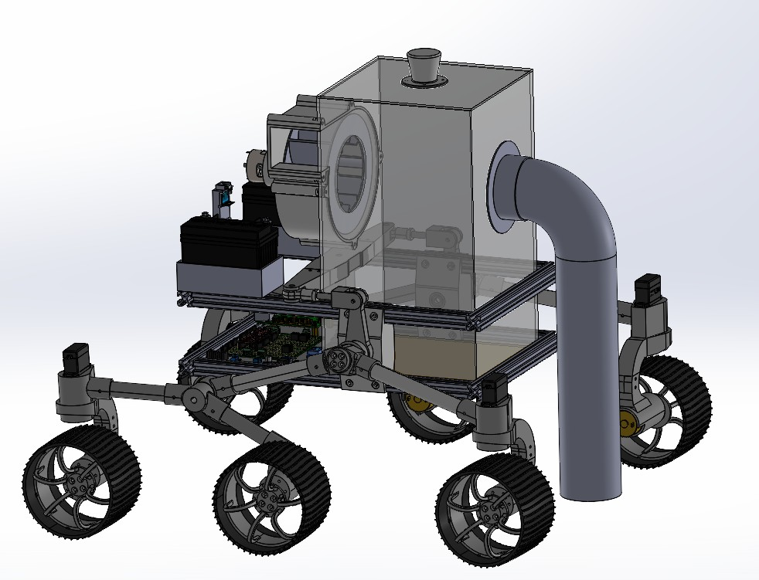

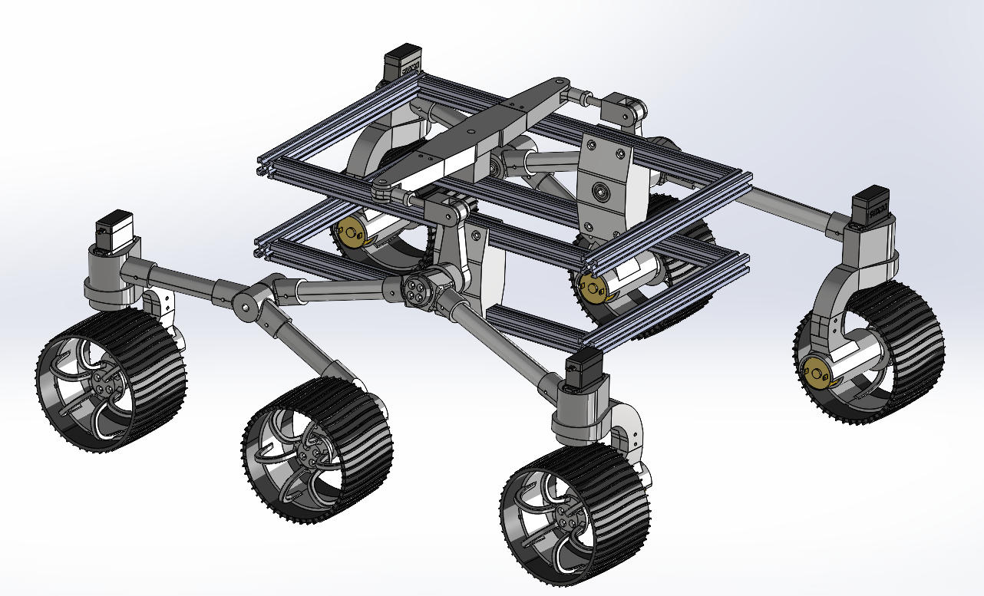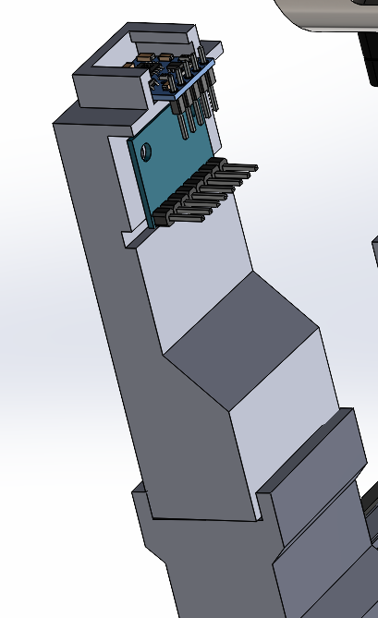

**2.1. Components and Parts**

**Materials**

* 20x20mm t-slot aluminum profile
* Acrylic plates
* 20 mm PVC pipes
* Duct Tube
* 3d-printed PLA parts
* T-slot nuts
* Regular nuts & washers
* Screws

**Electronic Components**

* 6x GB37 12V 250 rpm Geared DC Encoder Motor
* 1x RS775 12V Geared DC Motor
* 4x MG996R Servo
* 3x TB6612 Motor Driver
* 1x PCA9685 Servo Motor Driver
* 5x HC-SR04 Ultrasonic Sensor
* 2x XL4015 Step-Down Module
* 2x 12V Motorcycle Battery
* Logitech C922 USB Webcam
* Raspberry Pi 4B
* Arduino Mega

## **2.1.1. Electronic component design concepts**

### **Motor Drivers**

In order to control high torque DC motors efficiently, we need to be careful with the choice of motor drivers. We used L298N H-bridge drivers in earlier projects. That module dissipates a lot of heat and the voltage drop is higher than 1.4V. This time we decided to switch to TB6612FNG, a new MOSFET based H-Bridge driver with a small form factor.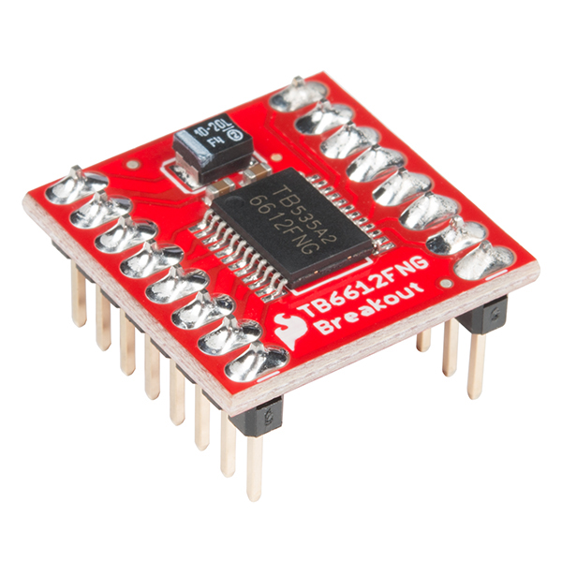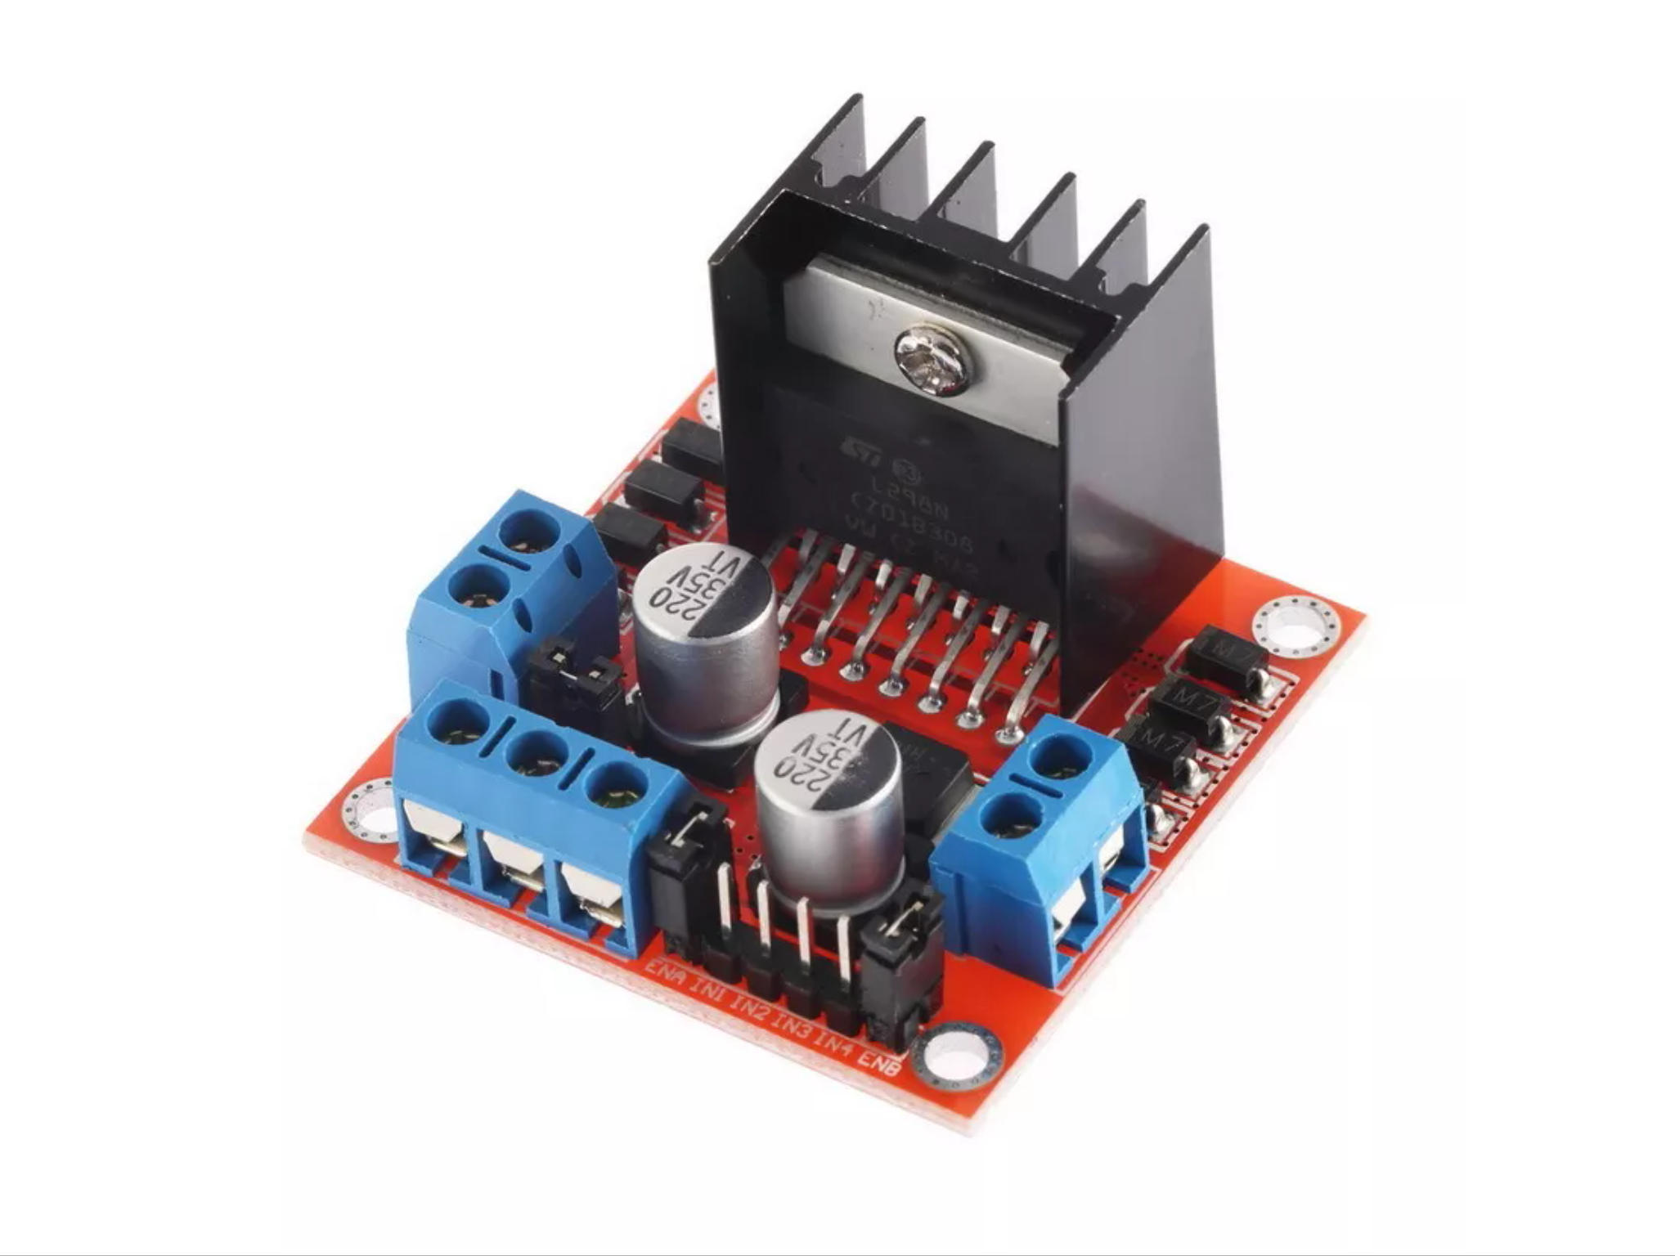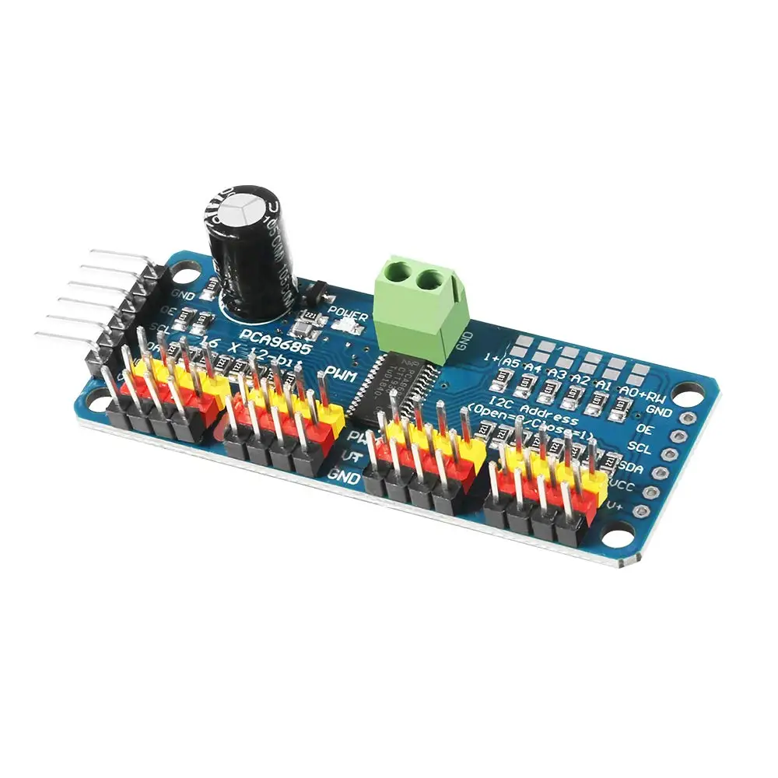

For **servo motors**, we need some module with robust and precise control. Thus, we decided to use a PCA9685 I2C 16-channels servo driver which supports 12 bit PWM.

### **Step Down Module**

In every robotic project, the most important factor is power distribution and power consumption. The robot needs to get required power (more or less) from the battery without any restrictions. The solution for that problem would be a step down module. This step down module can drive 3A when in full load. We used this module in two places. First, servo drivers. Servo needs a 5V power supply and the main power line is 12V. So, we needed to step down to 5V. Second, the impeller fan needs its maximum RPM (~3A). So, we connected the RS 775 motor with a step down module.

**Sensory Unit**

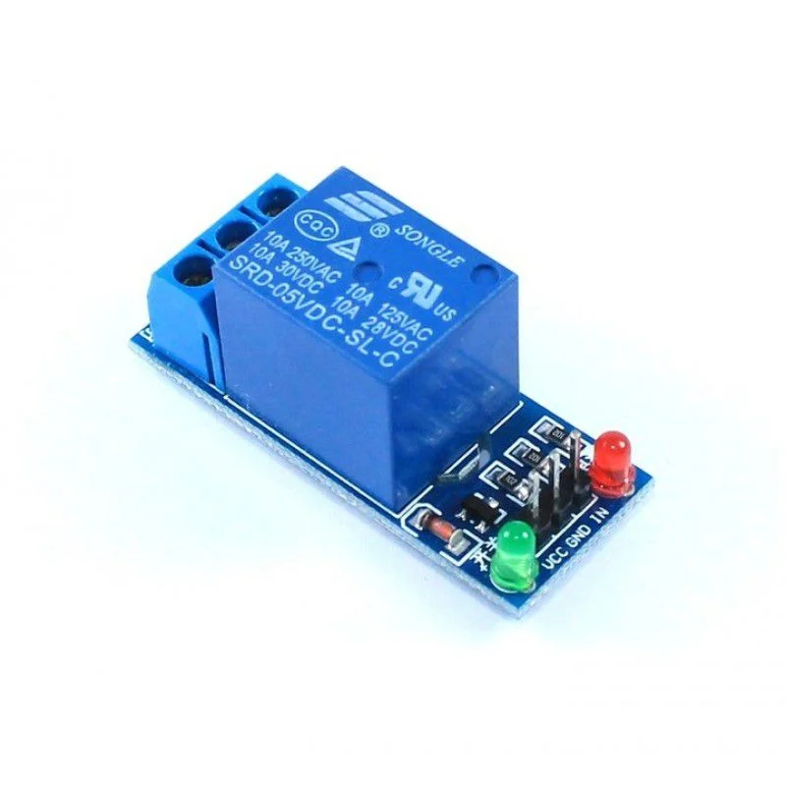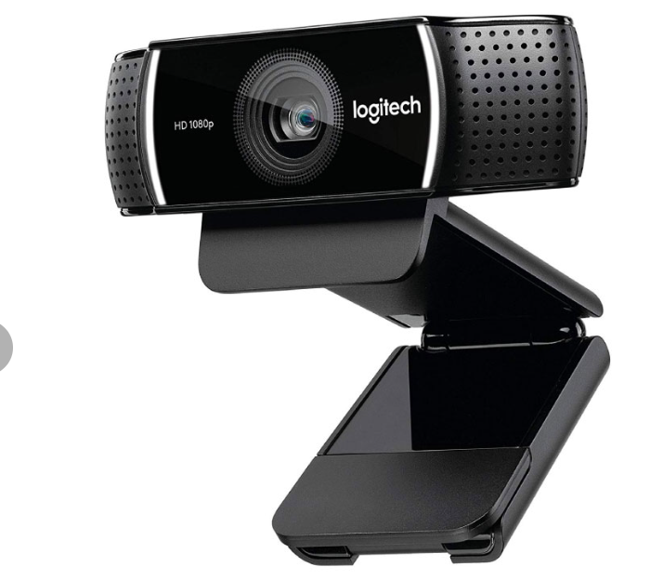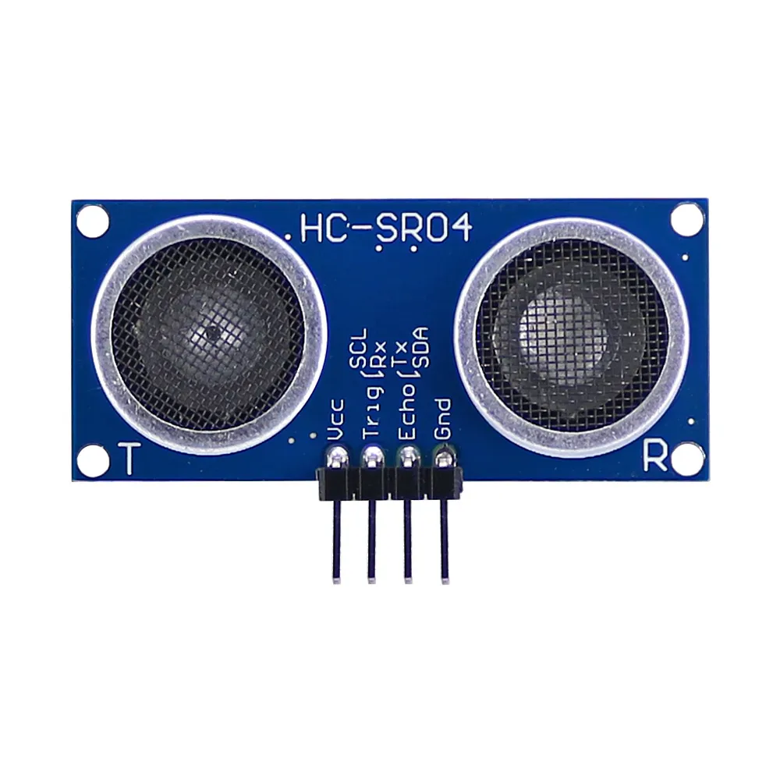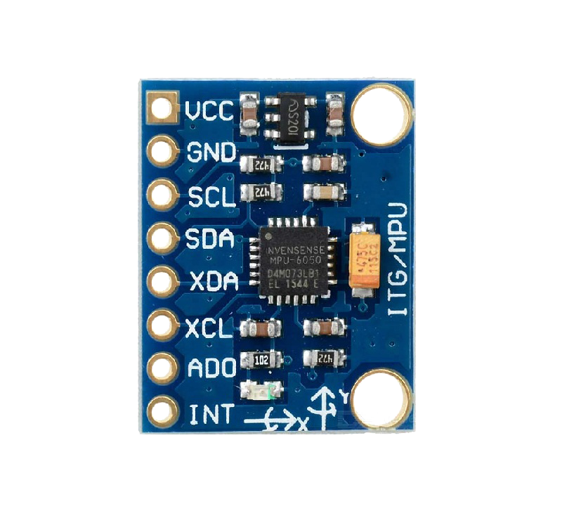

1. **Ultrasonic Sensors** - It was used for obstacle detection and to give feedback to our control algorithm and used for obstacle avoidance.
2. **Logitech Webcam** - It was intended to use as a visual input for the computer vision algorithm we designed.
3. **6-DOF Gyroscope and Magnetometer** - It was used as a navigation assistance that enabled the robot to know its current orientation in terms of row, pitch, and yaw values.
4. **Relay Module** - It was utilized as a controllable switch for the **Impeller-Battery** power line.

### 

### **Controller Unit**

The brain of the operation is Raspberry Pi 4 Model B. It takes feedback from various sensors, activates its control algorithms and sends commands to the motor drives(actuators). However, with Raspberry Pi’s limited pin count, we used an additional Arduino Mega to split the workload–**Raspberry Pi for sole calculation**(brain) and **Arduino Mega for actuation**(Limbs). These two controllers are connected by using I2C protocol to ensure seamless communication.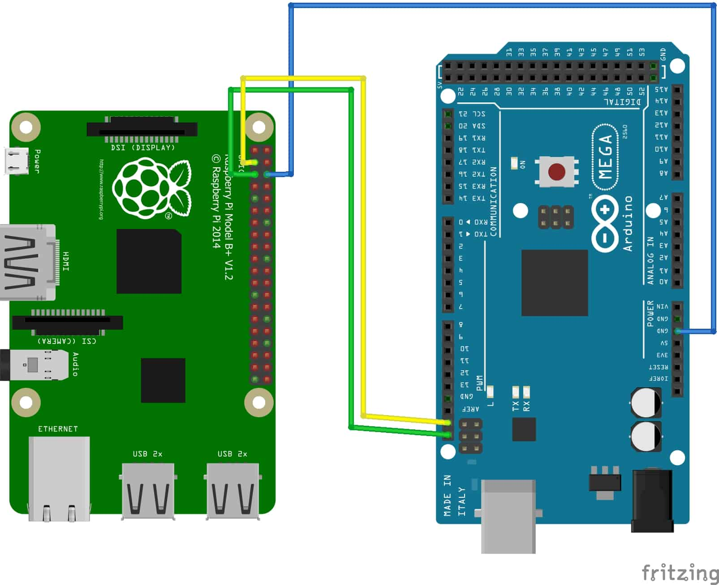

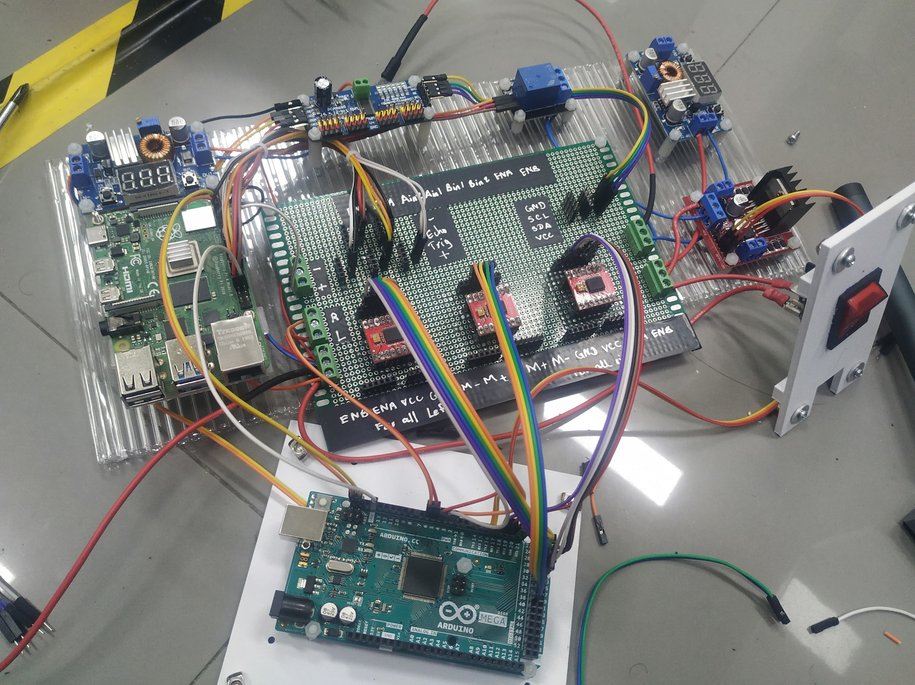

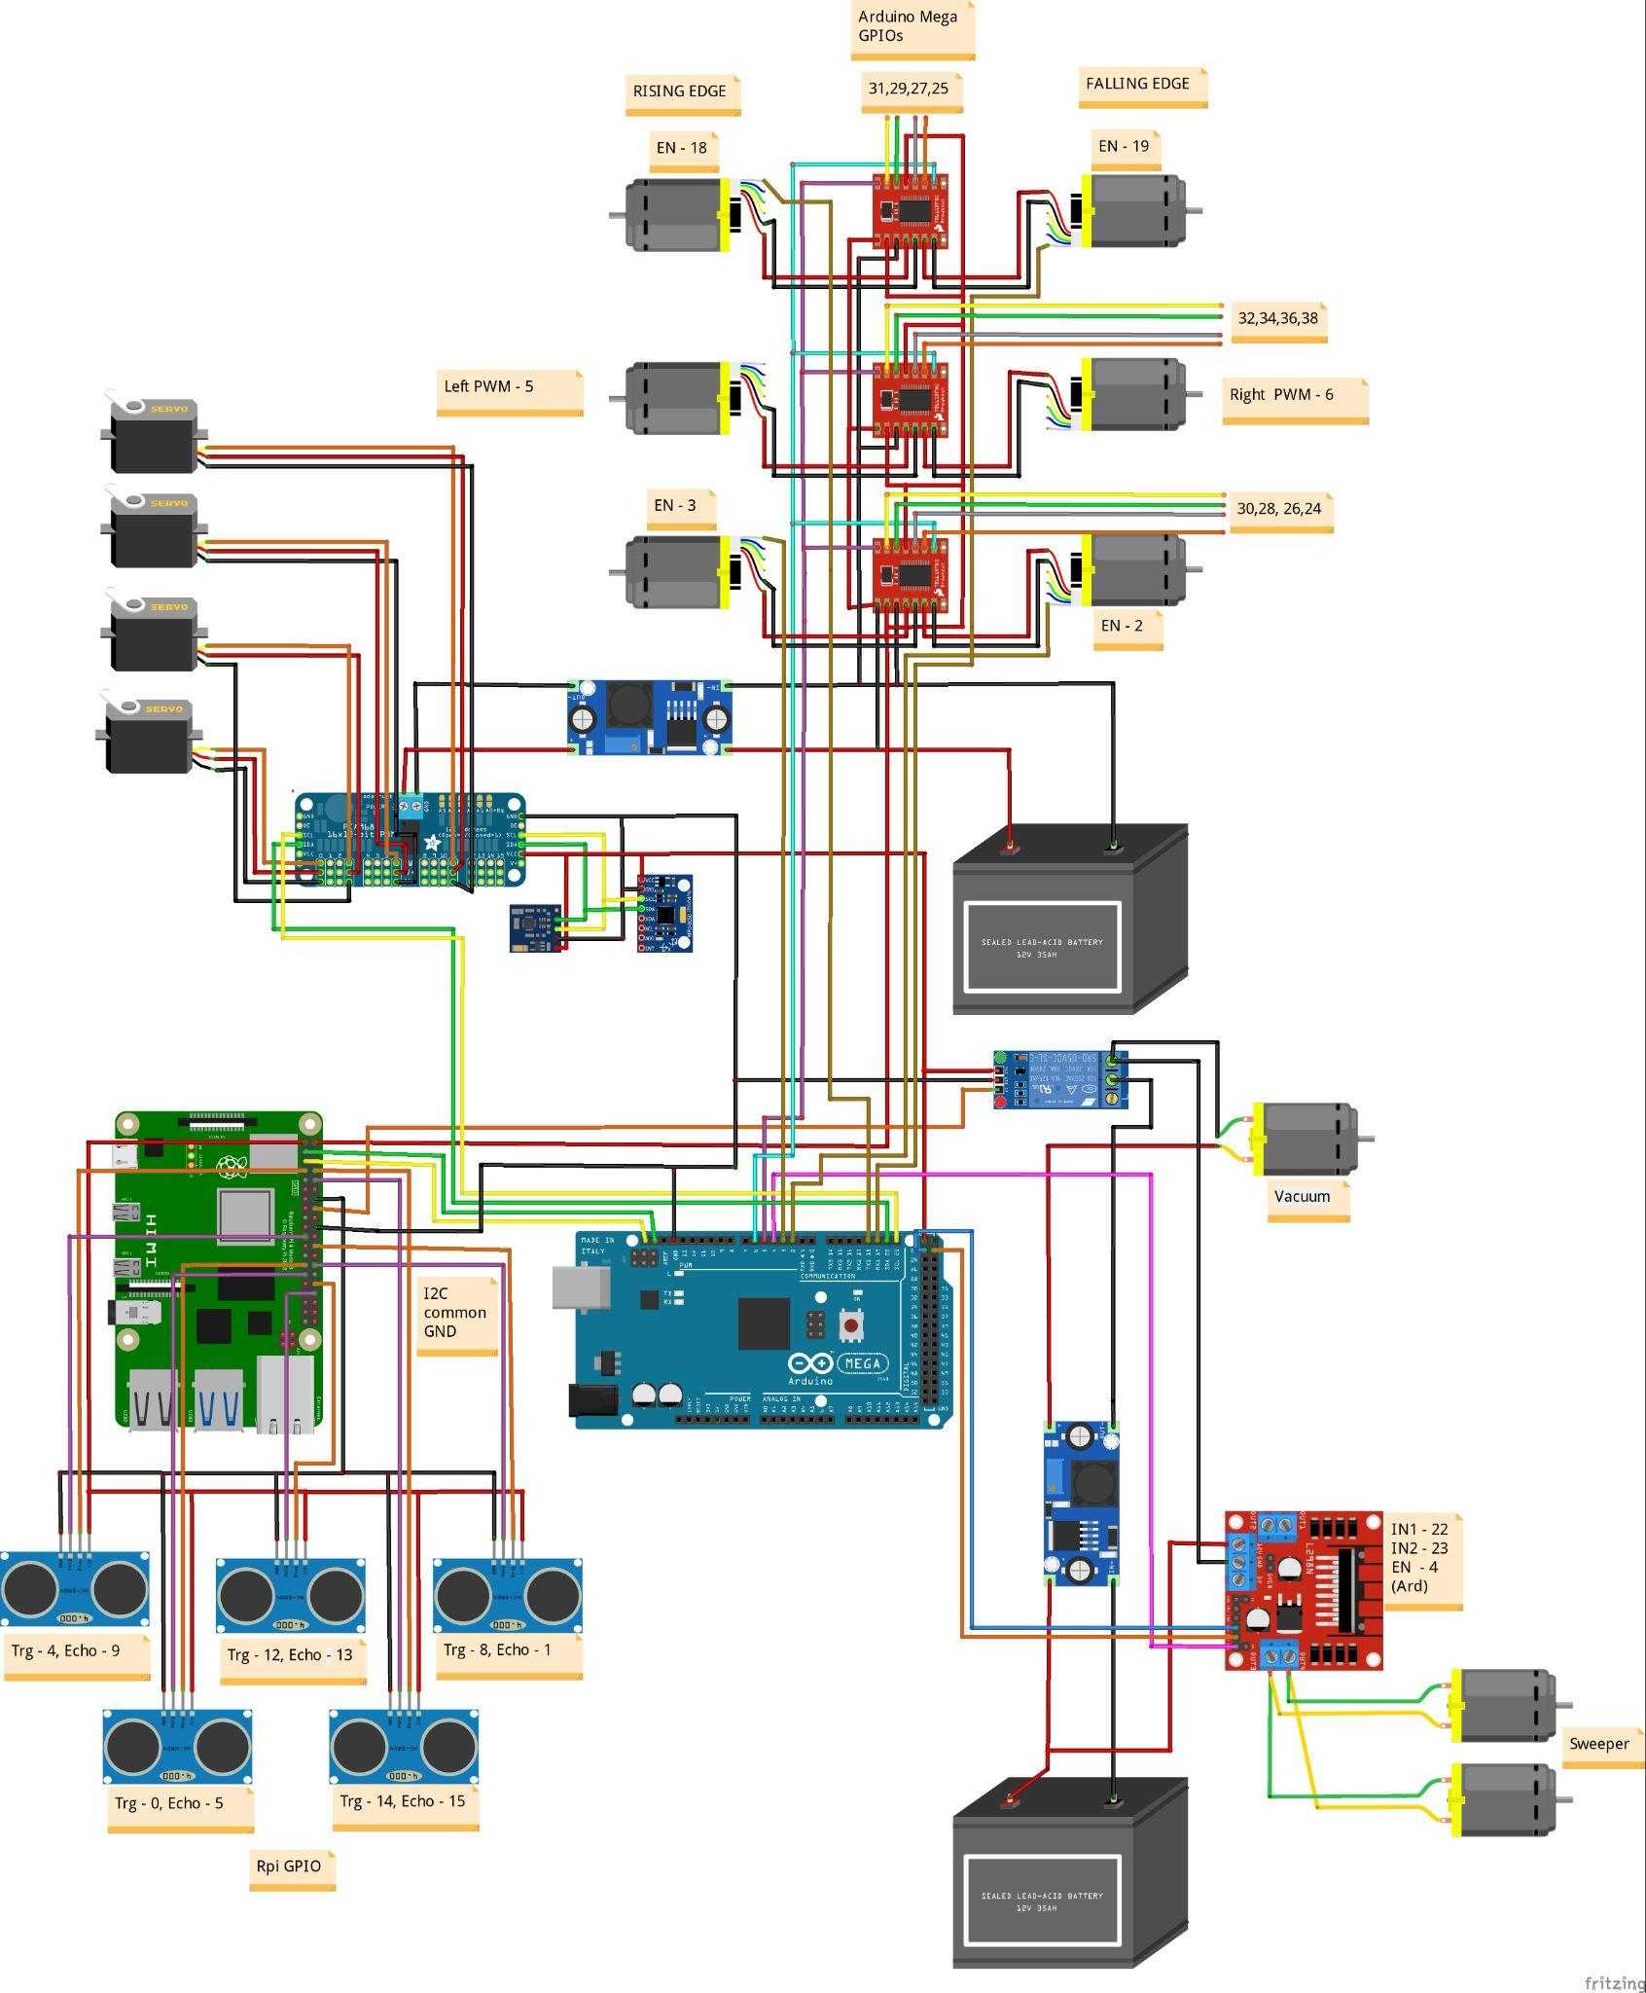

## 

## **2.2. Kinematics and Dynamics**

**Ackermann steering**

We did some modification on the Actual Ackermann Steering System and we calculated relative speed ratios of left and right wheels for turning speed.

Here is the calculation:

l = length of our robot

w = width of our robot

θ = angle of robot required to turn

$θ_{in}$ = angle of inner path wheel

$θ_{out}$ = angle of outer path wheel

R = turning radius of the robot

$R_{in}$ = turning radius for the inner path wheel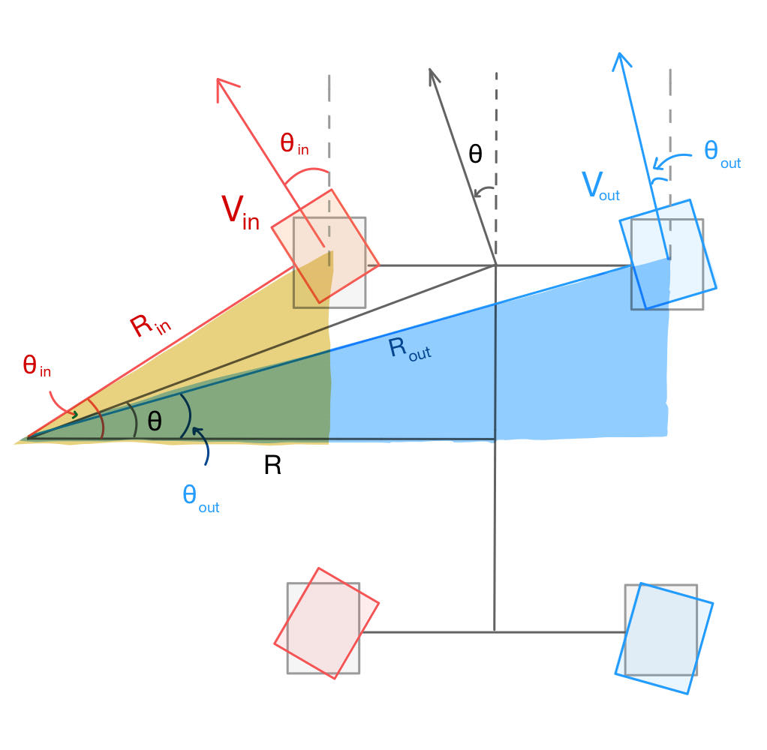

$R_{out}$ = turning radius for the outer path wheel

First we need to find the **Robot’s Turning Radius**

By using simple trigonometry,

R = $\frac{l/2}{tan θ}$

From R, we get the turning degree of each motor.

$θ_{in}$ = arctan ($\frac{l/2}{R - w/2}$)

$θ_{out}$ = arctan ($\frac{l/2}{R + w/2}$)

For controlling the velocity of the inner path and outer path wheels, we calculate the gain for PWM. This way we can control the velocity of each wheel making it smooth in turning.

$R_{in}$ = $\frac{l/2}{sin θ_{in} }$ $R_{out}$ = $\frac{l/2}{sin θ_{out} }$

gain ${PWM}_{in}$ = $\frac{R_{in}}{R_{in}+R_{out}}$ gain ${PWM}_{out}$ = $\frac{R_{out}}{R_{in}+R_{out}}$

## **2.3. Control System**

**Purpose: To be able to know the robot’s position relative to the original position**

We use encoder pulse values to know the distance traveled and we know the orientation of the robot from Magnetometer and Gyro.

Calculating number of pulse per revolution:

N = number of pulse per encoder revolution * gear ratio

N = 448 * 43.8 = 19622.4 pulse per revolution

Calculating distance traveled per revolution

d = 𝜋 * radius of the wheel

d = 𝜋 * 0.12 m = 0.377 m per revolution

State Equation (X = Ax + Bu)



State Matrix, **X =**

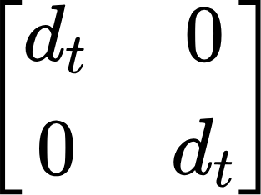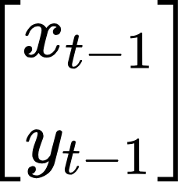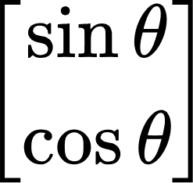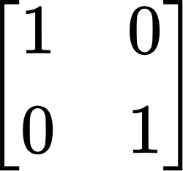

**A = ,x = ,B = ,u =**

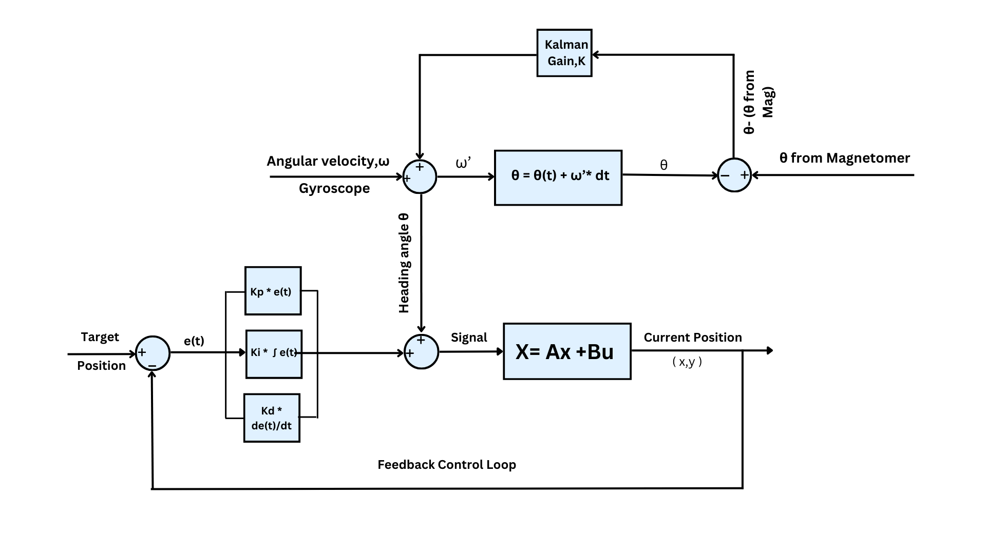

## 

## **Implementation**

## **3.1 Hardware**

**Chassis:**

We used a t-slot aluminum profile to build the frame of the chassis. Since aluminum is both strong and lightweight, it can be used to build a foundation for acrylic plates to be attached to. Furthermore, the t-slot on the aluminum profile helps for easy and sturdy assembly using t-slot nuts and bolts.

For stability of the robot’s body, we added the differential bar.

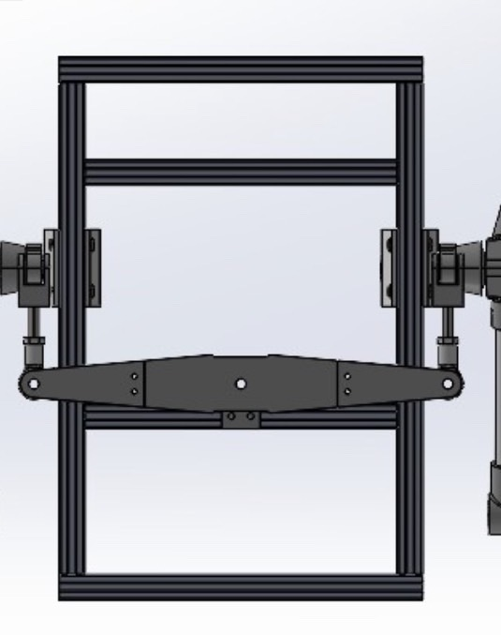 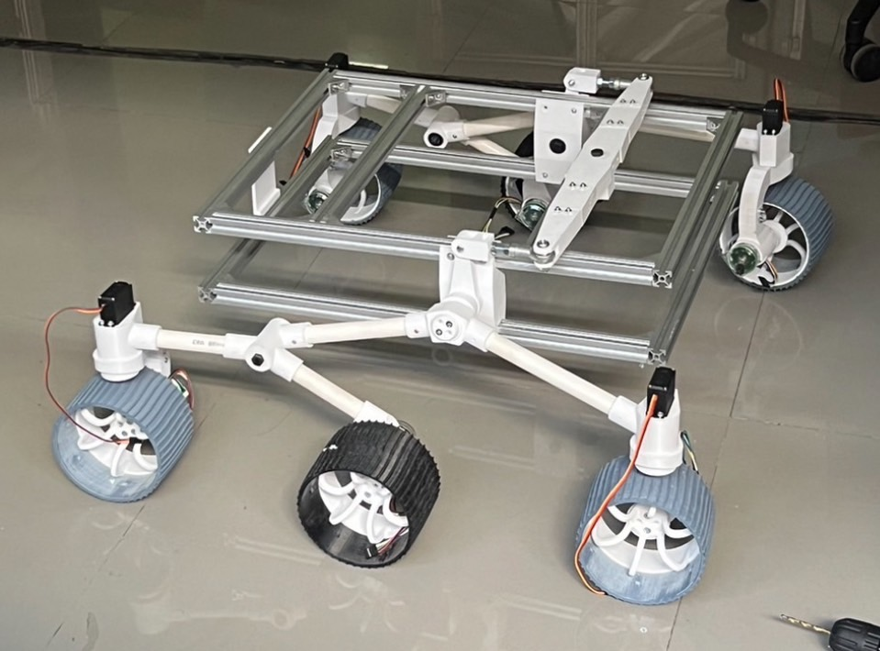

**Suspension:**

We built the Rocker-Bogie suspension system using PVC pipes and 3d-printed joints aiming to reduce the overall weight of the robot. The wheels are also 3d printed.

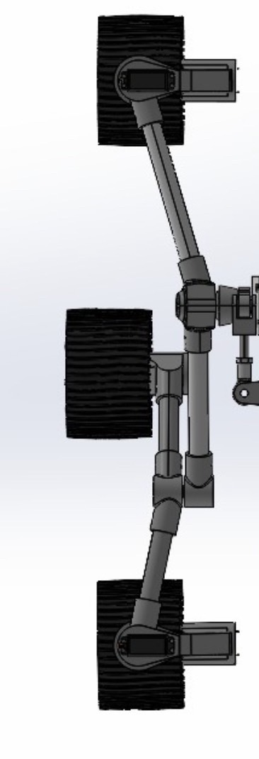

**Other implementations:**

* 3d-printed fan for vacuuming leaves
* Storage box made of glued acrylic plates
* 3d-printed ultrasonic sensor mounts and camera mount
* Using duct tube for the vacuum system

## **3.2 Software**

**Calibration of sensors:**

1. **Magnetometer**

Magnetic measurements from the magnetometer are subjected to distortion.

**Case 1: Hard Iron Distortions Case 2: Soft and Hard Iron Distortions**

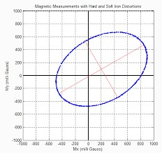

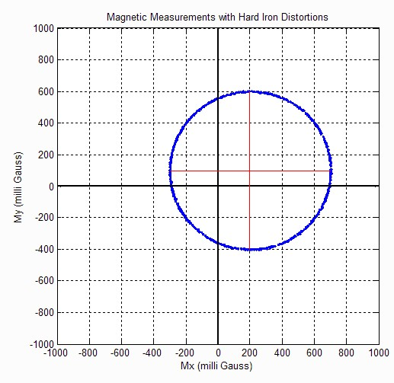

Hard iron such as magnet and current flowing coil could affect the magnetometer data to bias shifting from real measurements. Soft iron such as iron and other metals affect the shape of data to transform from circle to ellipse.

**Calibration Method:**

Step 1: Eliminating hard iron offsets from the raw data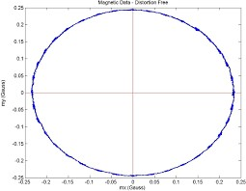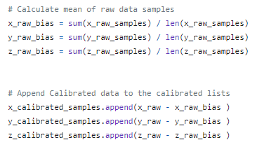

**Step 2: Applying linear transformation for soft iron distortions ( ellipse shape) fffffffffffffffff to form a circle**.

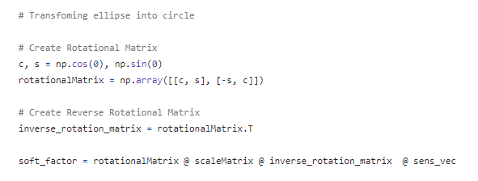

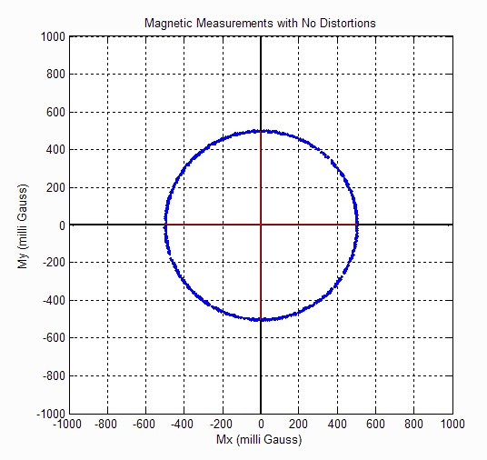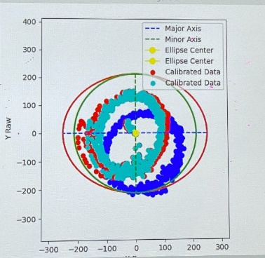

**Fig: No Distortion** **Fig: Calibration Result**

1. **Gyroscope**

Gyroscopes are susceptible to environmental vibrations, necessitating regular calibration before use to remove bias.

**Calibration Method:**

**Step 1: Enabling low pass filter**

We enable the low pass filter to reduce the vibrations caused by motors. 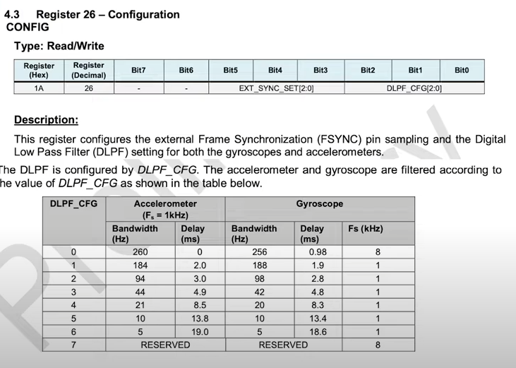





**Step 2: Choosing the sensitivity of gyroscope**

We chose the sensitivity of 65.6 LSB / degree/s

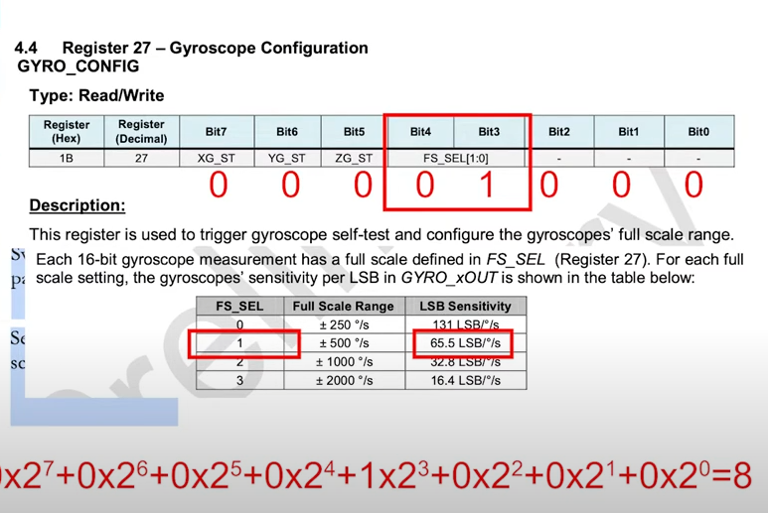





**Step 3: Scaling the raw data and calculating the bias**

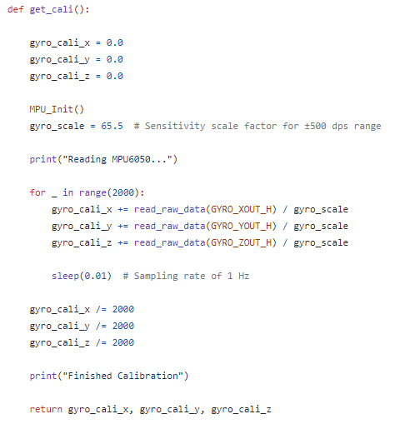

**Obstacles Avoidance**

**Ultrasonic sensor:**

Ultrasonic sensors require a little time interval to read the distance value, and this will cause delay to the whole system. We used the advantage of Python for parallelly reading ultrasonic sensors over time together with robot controlling by running the ultrasonic sensors coroutine in the background using Thread programming. The distance signal of these sensors were used as a trigger condition to send a request for an AI server.

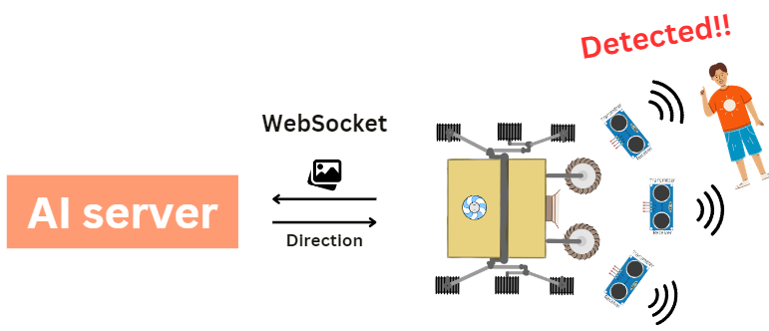

**Camera and AI:**

The segmentation AI was applied in this project to fusion with the ultrasonic sensors for obstacle avoidance tasks. With only the responses from ultrasonic sensors, we can observe only the existence of obstacles but not the size and exact position which is not enough for determining the direction of the robot to precisely avoid the obstacles. We used the fine tuning of SAM (segment anything model), the segmentation weight developed by Meta, to detect movable places. The advantage of SAM is that it can be fine tuned with prompts, such as bounding boxes and set of points, to increase the accuracy of the specific task.

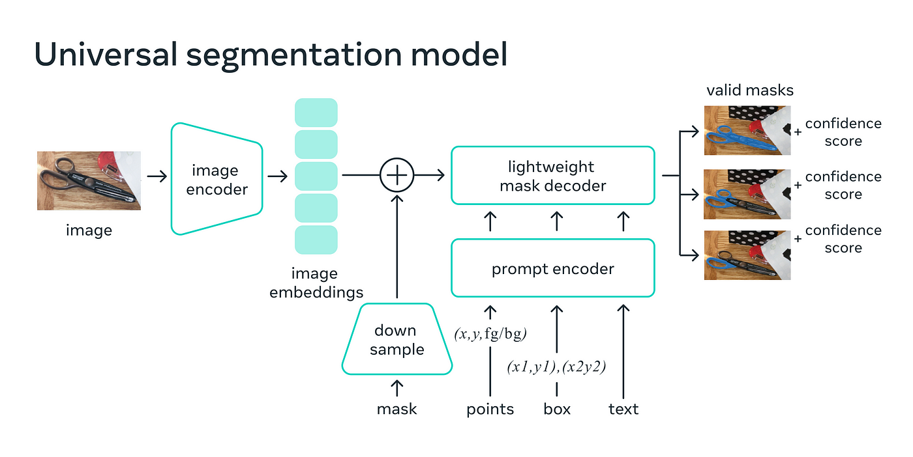

The figure above is the architecture of the SAM model showing that it has a prompt encoder available for extra parameters.

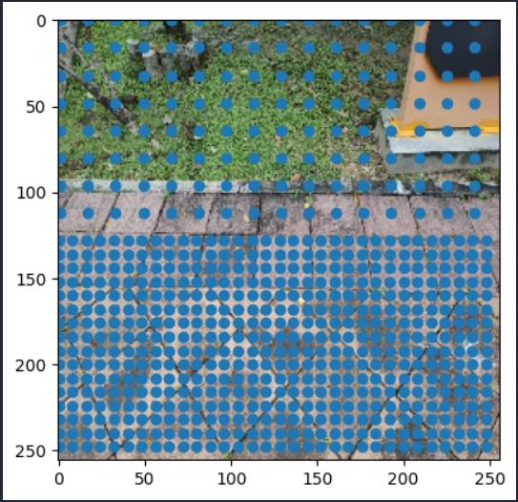

The figure above shows how we prompt the model in the fine tuning pretrained weight. As you can see, we feed the high density points into the bottom half of the image and few density points into the top half. With this prompting, it points the model to emphasizing on the closer area more than the farther area with respect to the position of the robot.

The figure above are the results of the fine tuning SAM model to detect the movable area. Yellow means no obstacle.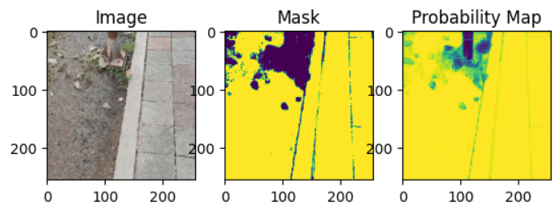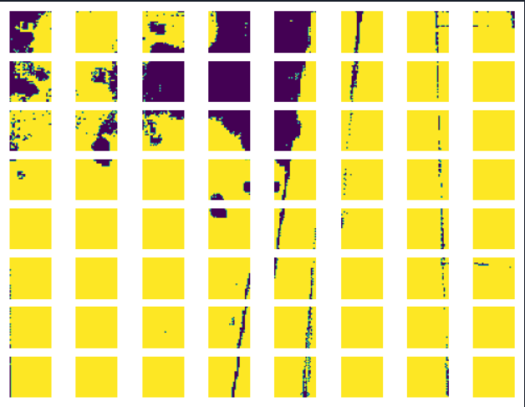

To calculate the direction of the robot, we split the detected image into small patches, then distinguish between movable and non-movable patches. The path finding algorithm will return the weight of each row from the bottom to top.

0 means the robot can move normally.

777 means either left or right, -777 means neither left nor right.

Positive means right, Negative means left.

The magnitude means how much should the robot turn.

**Controller**

**PID controller**

A PID controller technique was applied to make the robot move more stable. First, we set the target yaw position. Next, calculate for the error by subtracting it with the current position. 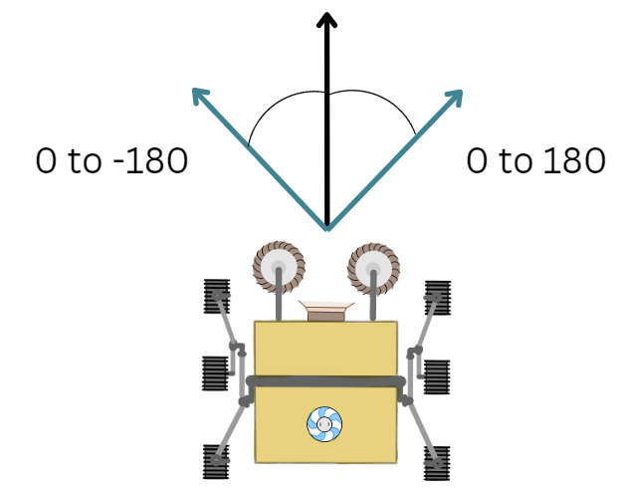

The figure above shows the position system that we used. Positive position means the robot needs to turn right (more left speed) and Negative position mens turn left (more right speed).

Here is how we calculated the PID using the stated principle.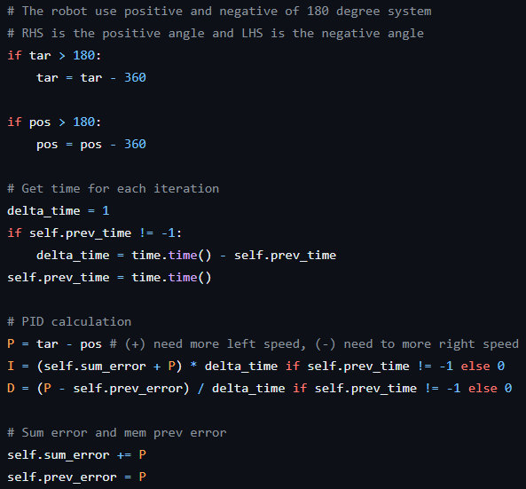

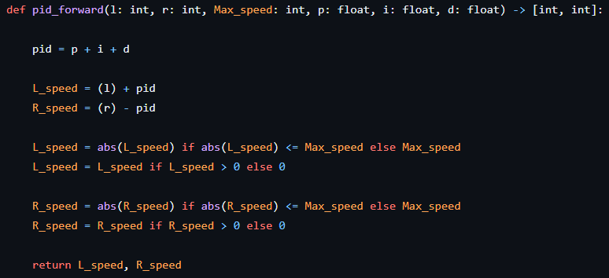

**API and Communication protocol:**

With only a single Raspberry PI 4B, it cannot handle all of the operations required to drive the robot due to the limitation of available pins and computational power. To solve this problem, we decided to separate each service into multiple microcontrollers and microprocessors in order to reduce the workload of Raspberry PI. There are 2 communication protocols used in this project.

1. **I2C:**

This protocol allows us to have a fast data transmission channel between Raspberry PI and Arduino using only 2 wires connection. We setted Raspberry PI as a master. Arduino and Servo driver as slaves. The data from the sensors was used to calculate the speed of the motors and direction of the servo motors in PI, then were sent to Arduino to control the H-bridge motor driver and Servo driver to determine the direction of each servo motor.

1. **MQTT and Websocket:**

These 2 APIs were used for different purposes. The MQTT was used for real time monitoring and adjusting the parameters of the robot. In our case, Raspberry PI is the publisher who publishes important parameters, such as PWM, servo angle and yaw from Kalman filter to any subscriber (the dev’s laptop in this case). The subscriber can observe those parameters and wirelessly adjust the PID constants in real time thanks to the MQTT. We decided to use the MQTT because of its abilities to transmit data in the unreliable network (Failure is acceptable), consume less memory and computational power, and quickly transfer a small package of data. 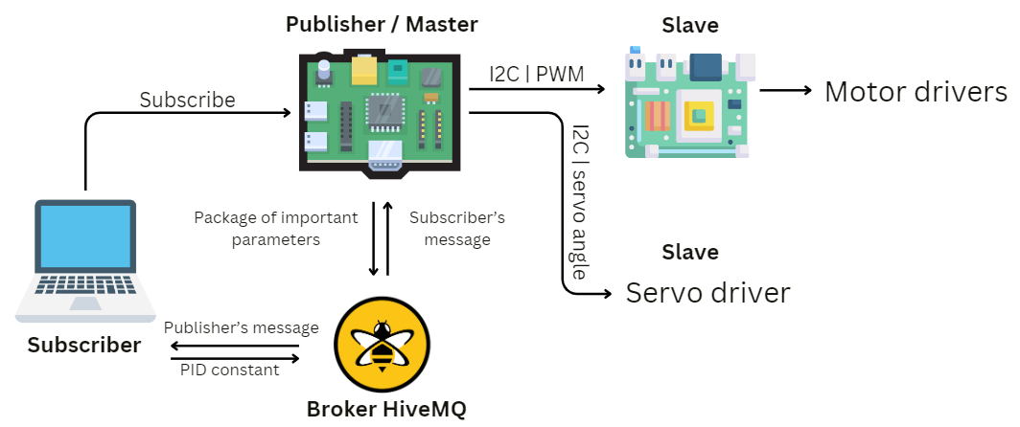

The Websocket was used for transferring the delicate data, image in our case. Websocket is more stable (Failure is not acceptable) and faster when we have to transfer a big package of data. The image will be feeded through the segmentation model in the server side, then send the data to PI or client side.

1. Implement a Kalman filter for sensor fusion(data fusion) of gyro sensor and magnetometer for yaw position calibration and giving the position for Ackerman turning .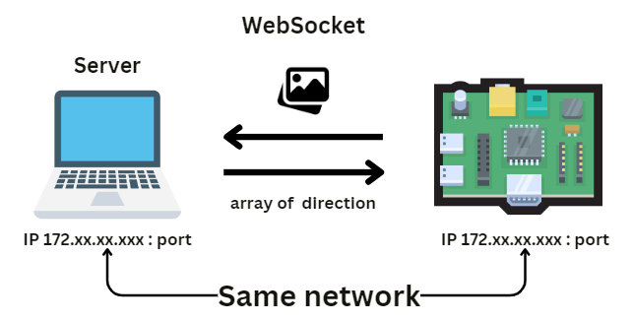
2. The Yaw position also feeds into the PID controller for robot movement speed controlling.
3. By creating a robot.py file for initial basic movement use for path planning in main file(main.py) which would handle all the function utilities from other sub-files that would be called on to and feed the data in.
4. On the sensors directory it provides all the necessity on sensor reading and calibration as well as motor control, for example we choose to manually access all the sensors using Smbus2 python library for more concrete and predictable output as we want.
5. We also chose I2C to communicate between raspberry-pi and arduino mega, which used to control the motor drivers separately from servo. Because of that we need a method to communicate between them.
6. I2C has advantages on speed of communication and it was relatively simple to implement and we can ensure that it would work in an environment that we want which requires the most lees wire for communication possible.

**Kalman Filter**

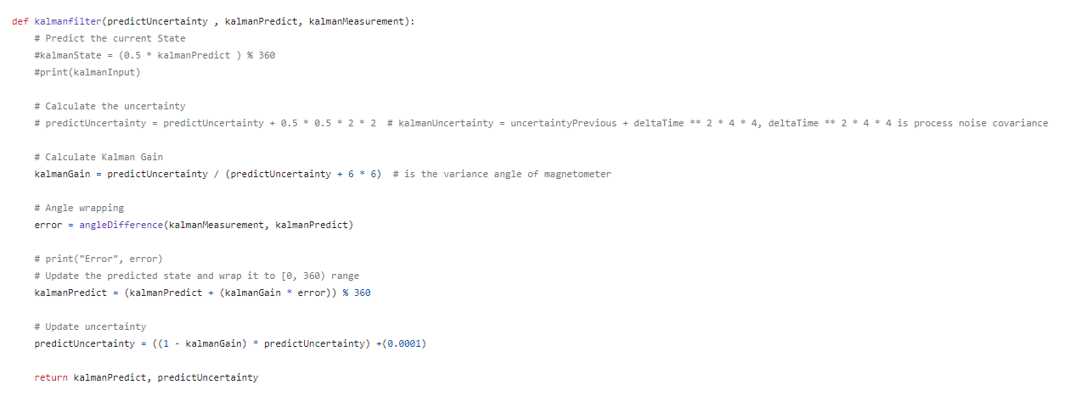

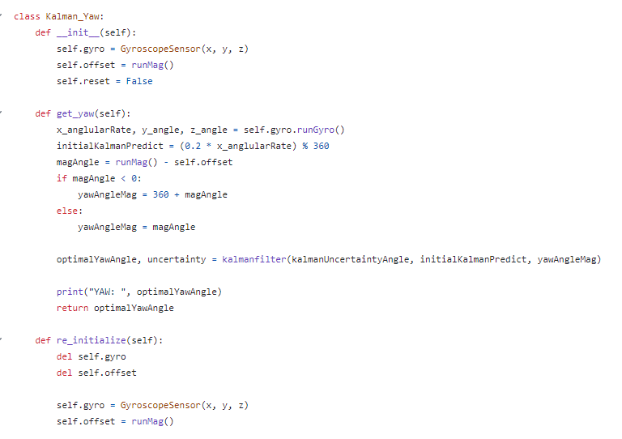

**4. Test Results**

1. **Overall result of our robot**

* In the given video below, you can see the robot is moving straight because of the pid controller.
* The turning mechanism calculated from Kalman filtered optimal degree and ackerman steering also works as expected.

**Youtube Link -** [**https://youtu.be/87p56Rra9FQ?si=ri9Iy3AmIpDKeXMY**](https://youtu.be/87p56Rra9FQ?si=ri9Iy3AmIpDKeXMY)

1. **Kalman filter**

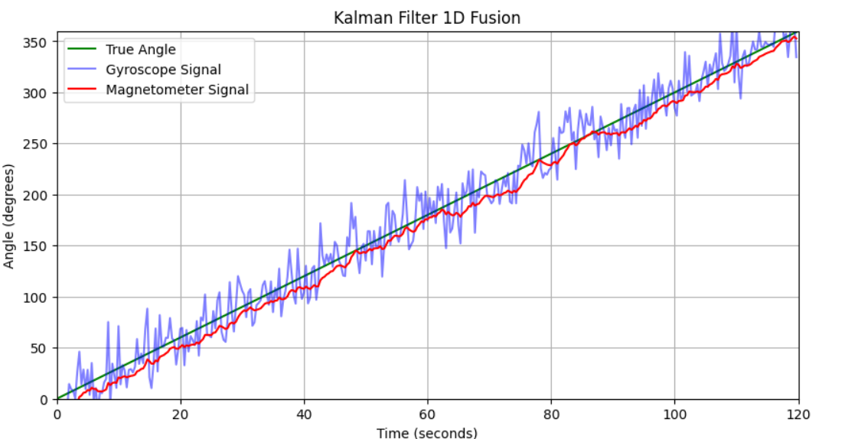

With Kalman filtering, the result of orientation(Degree) is very precise with only $±$ 2 degrees of variation in each test.

1. **PID controller**

The PID controlling worked as intended although the problem is more likely to be with the power of the motor that it cannot pass through the tall grass section as the encoder-motors have too low of a power to push through it.

1. **Sensor Calibration** 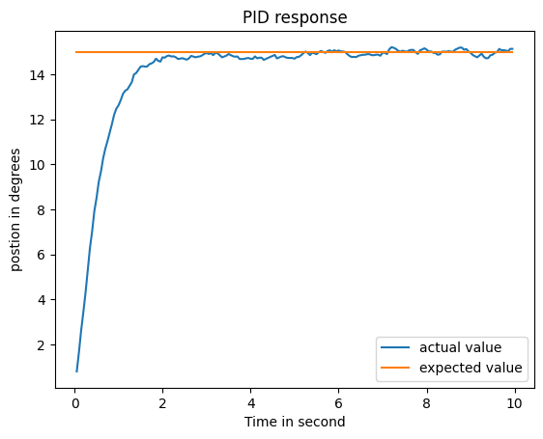

**Magnetometer**



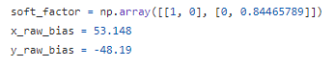

* This is the transformation matrix and bias value to get the best result angle measurement of magnetometer

1. **Conclusion**

**Concluding Remarks**

In conclusion this project expanded our expertise in many ways for example, in using the Kalman Filter for filtering noise and errors of the data from sensors, and also fusion the data together to get the true position of the robots. And we have gained the experience of working as a large team from the start. Finally we can learn to adapt and adjust the spec of our robots to suit our budgets.

**Suggestions**

1. Changing the navigation method for the robot for example instead of using time intervals for a predicted routine we can change to using a SLAM map and PURE PURSUIT method for completely automating navigation. In that way we can just use the waypoint from the map and let it handle the path plan by itself.
2. Changing the structure for the rover skeletons that used PVC pipes as a structure support, Due to the overall weight of the robot is higher than expected can it’s the way to cut the cost of the robot. If possible we could use metal pipes instead of PVC pipes.

**Project Code Github :** [**https://github.com/ptkoo/leave_collector_robot.git**](https://github.com/ptkoo/leave_collector_robot.git)

**Member Participation**

